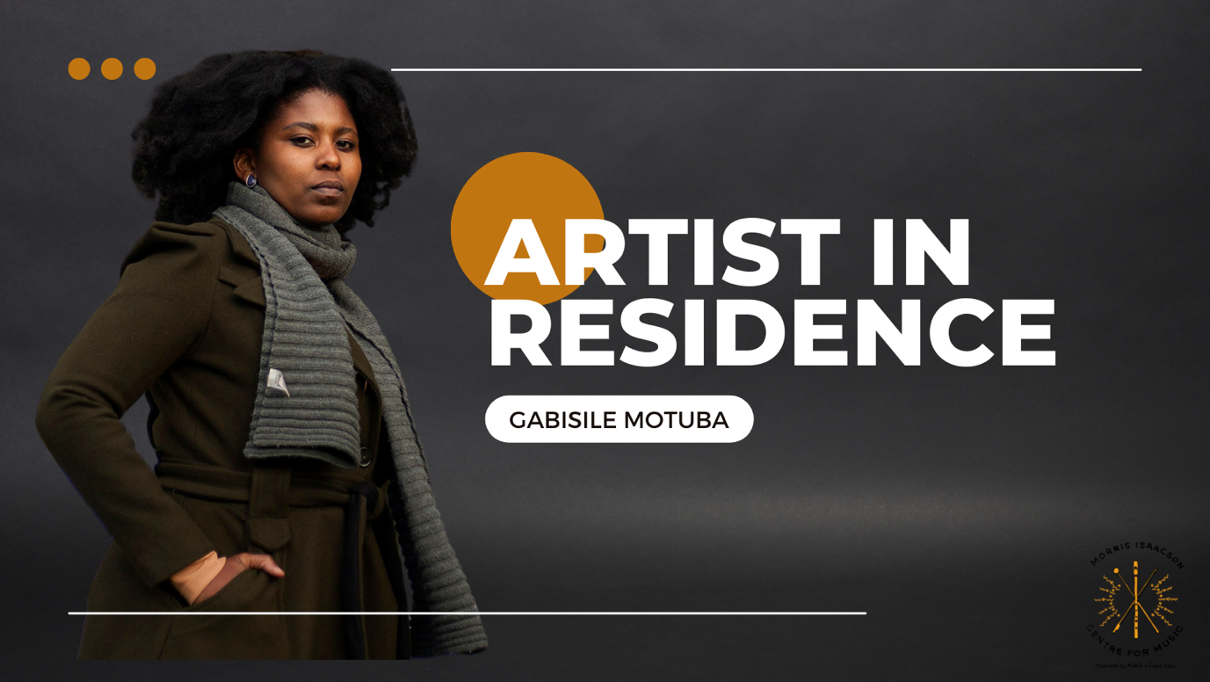

**BRIDGING GAPS FOR YOUNG COMPOSERS**

**PRESS RELEASE**

The Morris Isaacson Centre for Music (MICM) - is a music centre, located in Central Western Jabavu committed to driving human development through music by enabling access to world class music education to more than 326 children in Soweto between ages of 4 and 18. The centre is located on one of the most historically important high schools in South Africa, known as Morris Isaacson Secondary School.

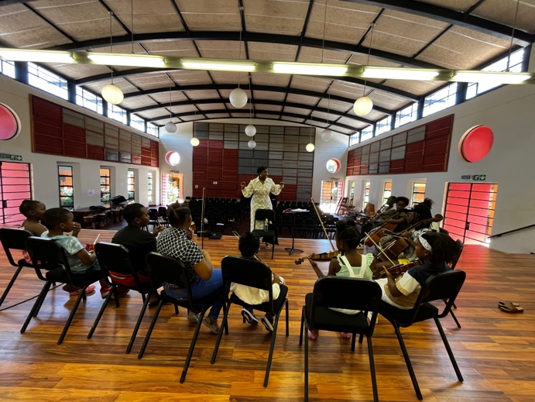Morris Isaacson Center for Music is proud to announce Gabi Motuba as their first ever Artist In Residence from 01 February to 30 April 2023. The purpose of the residency project is to develop a new and exciting curriculum, focusing on composition, for the MICM students. Gabi Motuba is set to layout a better understanding of musical expression for the development of a unique approach to one’s musicality and storytelling using Music Theory techniques, Instrument, Music History, Sound Art and Technology and finally Expression.

The residency introduces the MICM students to the art of composition classroom as well as exploring new innovative techniques of creating and interpreting music. The curriculum focus will include the methodology of African American composer musician Butch Morris and his theory on Conduction.

In conclusion of the workshops, our MICM students will be showcasing what they have learnt to their parents, peers and MICM community at large. We are having a concert on 29 April 2023 and we would like to invite the community of Soweto and wider to come and share the joyous event with us. We will have music performances by our MICM students who have been participating in the composition workshop and a special performance by Gabi Motuba’s band.

The event will take place from 17:00 – 19:00. Drinks and refreshments will be sold.

Tickets are R50.00 and will be sold on Web tickets or cash at the door.

